Interactive Lessons # 1 - Static Electricity
Calculus Physics 2

We will be using the University of Colorado’s physics simulations called PhET interactive simulations in Physics for this Interactive lesson.

Go to the link below
Balloons and Static Electricity - Static Electricity | Electric Charges | Electric Force - PhET Interactive Simulations (colorado.edu)
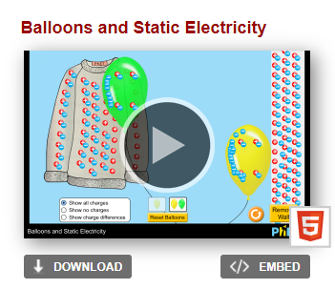
or go to

https://phet.colorado.edu/en/simulation and Click on the “Balloons and Static Electricity” simulations

Note: You may need to search for the site then open in your browser in order to get the simulation to work.

Click on the play button, you should have an image similar to the one below.

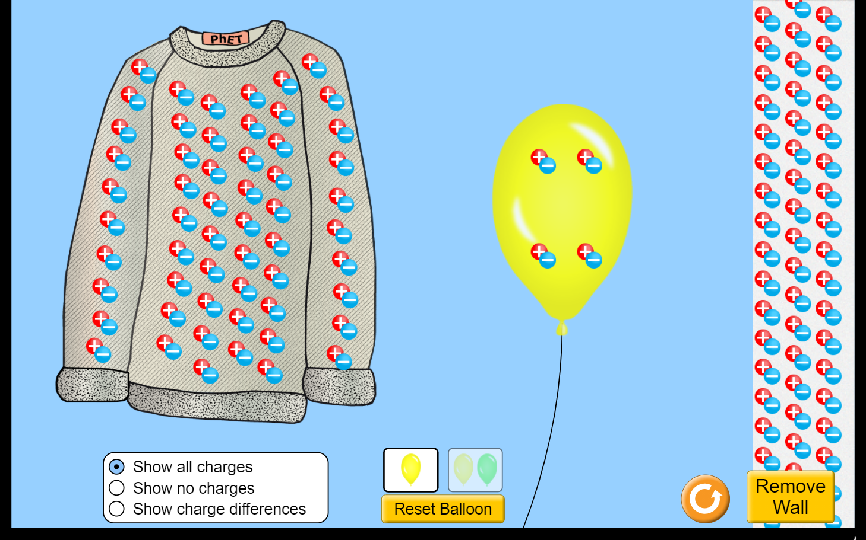
Set what charge is shown
Wall with neutral charge showing
One or two balloons
charge
Reset charge
The electrons (blue) charge will transfer to balloon
- First get familiar with the activity, left click and drag the single balloon towards the wall then to the sweater. Play around with the simulation to figure out how it operates.
- Use only a single balloon for this activity.
- Keep the “show all Charge” and the do NOT remove the wall.
- If you hit the reset button you will have to re-set all settings.

Learning Objective for this simulation.
- Explain how a net charge is created and conservation of charge.
- Describe the polarization effect and how a charged object is attracted to a neural object.
- Observe break down in air and the factors that affect it.

Activity # 1 – Reset the charge so all objects are neutral then drag the balloon towards the wall to the right

Question 1) Describe what happens to the charge on the neutral balloon as the balloon approaches the wall.

Question 2) Describe what happens to the charge on the neutral wall as the neutral balloon approaches.

Question 3) Explain why the charge on the balloon and wall would behave this way?

Question 4) Would the balloon stick to the wall, explain why or why not?

Now move the balloon towards the sweater, “rub” the balloon by moving the balloon over the entire sweater.

Question 5) What happens to the red and blue charge on the balloon?

Question 6) What happens to the red and blue charge on the sweater?

Question 7) Now move the balloon away from the sweater to the right and release the balloon, describe what happens and why?

Activity # 2 – With the balloon still fully charged, move the balloon to the right next to the wall.

Question 8) Explain what happens when the charged balloon to the charge on the neutral wall and why?

Question 9) Does the balloon stick to the wall explain why or why not? What has changed about the situation from Activity # 1?

Question 10) Place the charged balloon half way between the sweater and the wall and release the balloon, explain the motion of the balloon, why does it move the direction it does?

Activity # 3 – Reset the charge to neutral.

Question 11) Set the charge to “show charge differences” and repeat the above experiment with the charged balloon next to the wall, does this make sense, briefly explain?
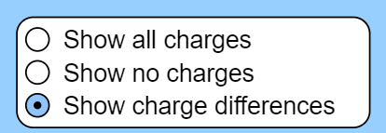

- Close this simulation

Activity # 4 - Go to the Simulation “John Travoltage”
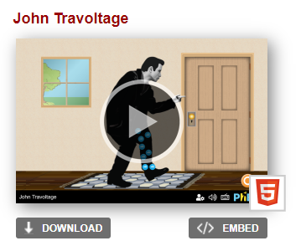
John Travoltage (colorado.edu)

or go to

https://phet.colorado.edu/en/simulation and Click on the “John Travoltage” simulations

Click on the play button

You should have an image similar to the one below before you start answering questions.
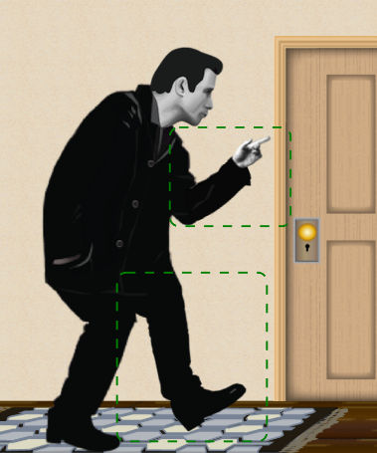
- Left click and hold to move the foot or the hand/finger.

Move Johns foot back and forth on the rug (do not adjust his finger)

Question 12) Explain what happens with the charge when you move John’s foot?

Question 13) What eventually happens to the charge when you keep rubbing the foot on the rug?

Question 14) Why does it take a certain amount of charge build up in order to discharge, why does it not discharge as soon as it is created?

Move John’s finger away from the doorknob and charge John by rubbing his foot on the rug.

Question 15) What are the changes if any when you move the finger away from the doorknob?

Move John’s finger near the doorknob then charge John

Question 16) What changes if any are there when you move the finger close to the doorknob?

- When complete Upload this Lesson to this assignment in Canvas.

